University of Waterloo

Midterm Examination

E&CE 355
Software Engineering
(Sample Solutions)

26/10/2005

Instructor

Kostas Kontogiannis

This exam has four questions, and is marked out of 110. The examination is 90 minutes long. This is a closed book exam. No additional material is allowed.
Unauthorized duplication or archival of these questions is not permitted. To be returned with the exam booklet after the completion of the exam.
Read to the description of a system below and answer the questions following it.
A product is to be installed to control elevators in a building with m floors. The problem concerns the logic required to move elevators between floors according to the following constraints:

- Each elevator has a set of m buttons, one for each floor. These illuminate when pressed and cause the elevator to visit the corresponding floor. The illumination is canceled when the elevator visits the corresponding floor.
- Each floor, except the first floor and top floor has two buttons, one to request and up-elevator and one to request a down-elevator. These buttons illuminate when pressed. The illumination is canceled when an elevator visits the floor and then moves in the desired direction.
- When an elevator has no requests, it remains at its current floor with its doors closed.

The basic course of Action for elevator scenario:

• Passenger presses floor button (that is the button on the wall).
• Elevator system detects floor button pressed.
• Elevator moves to the floor.
• Elevator doors open.
• Passenger gets in and presses elevator button (that is the button in the cabin panel).
• Elevator doors close.
• Elevator moves to required floor.
• Elevator doors open.
• Passenger gets out.
• Elevator doors close.

Q1. (Pertaining to Sequence and Collaboration Diagrams) (30 points)

- Draw the Sequence diagram pertaining to the floor button (10 points)
- Draw the Sequence Diagrams pertaining to the elevator button (10 points)
- Draw the Collaboration Diagram pertaining to floor button (10 points)

Answer 1.1
.
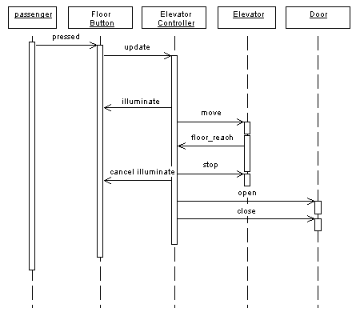
Ref. http://www.geocities.com/SiliconValley/Network/1582/uml-example.htm

Answer 1.2

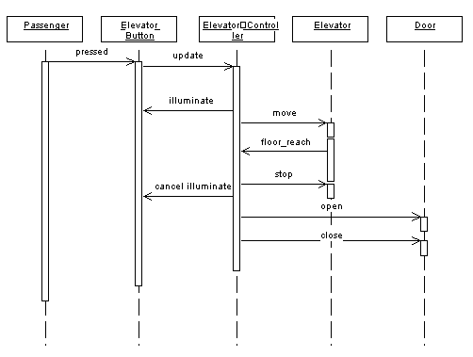
Ref. http://www.geocities.com/SiliconValley/Network/1582/uml-example.htm

Answer 1.3.

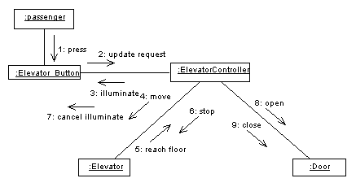

Ref. http://www.geocities.com/SiliconValley/Network/1582/uml-example.htm

Q2. (Pertaining to UML Class and State Diagrams) (20 points)
- Draw the detailed class diagram for the elevator system (10 points)
- Draw the State diagram for the floor button (10 points)

Answer 2.1

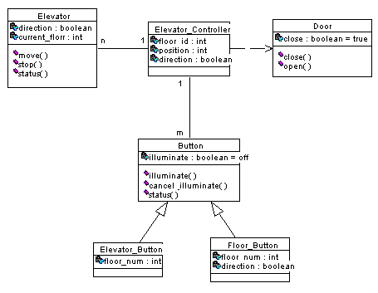
Ref. http://www.geocities.com/SiliconValley/Network/1582/uml-example.htm

Answer 2.2

On
Off
Button pressed
Elevator arrives in correct direction
Elevator arrives in wrong direction
Button pressed
Elevator arrives in floor

Read to the description of a system below and answer the questions following it.

Basic Course of Action for Enroll in University scenario:

1. An applicant wants to enroll in the university.
2. The applicant hands a filled out copy of University Application Form to
the registrar.
3. The registrar clicks on the Create Student icon.
4. The system displays Create Student Screen.
5. The registrar inputs the name, address, and phone number of the applicant.
6. The system checks whether the applicant is on the applicants list and whether
they already exist within the system.
7. If the student is on the applicants list but not already on the system, then a record is
created.
8. The student enrolls in courses.
9. The system calculates the required initial payment.
10. The system displays Fee Summary Screen.
11. The student pays the initial fee.
12. The system prints a receipt.
13. The registrar validates and gives the student the receipt.
14. The use case ends.

Q3. (Pertaining to Domain Model, Activity and, Use Case Diagrams) (30 points)
  - Draw a Domain Model Class Diagram that is the high level class diagram without
any data members or methods (10 points)
  - Draw a UML activity diagram for the enroll in University scenario above
covering the steps 1-14. (10 points)
  - Draw a UML Use Case Diagram for the above scenario (10 points)

Answer 3.1

Answer 3.2

Fill forms
Forms
Input Forms
Get record
Verify student
Create Record
Calculate Fees
Pay Fees
Issue Receipt
Receipt
yes
No
Stop
End
Start
Record

Answer 3.3

Registration System
Registrar
Applicant
Fill Form
Select courses
<<include>>
Pay Fees
Obtain Receipt
Calc. fees
Verify Student
Issue Receipt
<<requires>>
<<requires>>
<<include>>
<<requires>>

Q4. (Pertaining to Process Models) (10 points)
- Provide the general diagram of an Evolutionary Process model and briefly explain its major characteristics in one paragraph or bullet form (5 points)
- Provide the general diagram of an Incremental Process model and briefly explain its major characteristics in one paragraph or in bullet form (5 points)

Answer 4.1

Design
Coding
Test
Deployment
Requirements
Design
Coding
Test
Deployment
Requirements
Design
Coding
Test
Deployment
Requirements
Feedback
Version 1
Version 1
Version 1

New versions implement new and evolving requirements

- Advantages
  - Constant customer involvement and validation
  - Allows for good risk management
- Disadvantages
  - Build-and-fix danger
  - Contradiction in terms

Answer 4.2

Design
Coding
Test
Deployment
Design
Coding
Test
Deployment
Design
Coding
Test
Deployment
Requirements
Release 1
Release 2
Release 3

Each release adds more functionality, i.e., a new increment
Operational quality portion of product within weeks

Q5. (Pertaining to Architecture) (20 points)
- Provide the diagram of 4+1 Architecture View Model and briefly define the different Views (10 points)
- Provide an example of the operation of a system conforming to A Mixed Push-pull Pipe and Filter Architecture With Passive Source. and Sink. Use a sequence diagram to illustrate the operation (10 points)

Answer 5.1

Figure form slides, and

- The logical view describes the (object-oriented system) system in terms of abstractions, such as classes and objects. The logical view typically contains class diagrams, sequence diagrams, and collaboration diagrams. Other types of diagrams can be used where applicable.
- The implementation view describe the structure of modules, files, and/or packages in the system. The package diagram can be used to describe this view.
- The process view describes the processes of the system and how they communicate with each other.
- The deployment view describes how the system is installed and how it executes in a network of computers. Deployment diagrams are often used to describe this view.
- The use case view (+1) consolidates all views through use cases and scenaria.

Answer 5.2

dataSink
filter1
pull/push
dataSource
filter2
pull
f1(data)
f2(data)
data:=read()
data:=read()
write(data)

